
Assignment Front Cover Sheet

Student Name: | Bikkumalla Anish
Student ID: | 17000385
Degree Title: | MSc Global Finance
Level: | RQF LEVEL 7
Module Title: | Portfolio Management and Risk Analysis
Module Code: | 7020MECO
Seminar Lecturer: | Binsheng Qian , Sanjana Nagpal

Assignment Title: | Risk Assessment and Portfolio Management Report
Word Count: | 4172

Link:  To shared files, wordpress.com Blog, etc. | [Insert link here if relevant]

By submitting this assignment, I confirm that:

- I have read and understood the University’s Academic Integrity Guidance and that in the attached submission I have worked within the expectations of the Regulations Governing Academic Integrity.
- I am aware that failure to act in accordance with Appendix 1 of the General Regulations may lead to the imposition of penalties which, for the most serious cases, may include termination of studies.
- I consent to the University copying and distributing any or all of my work in any form and using third parties (who may be based outside the UK/EU) to verify whether my work contains plagiarised material, and for quality assurance purposes.

Academic Integrity Declaration:

I, Bikkumalla Anish, am aware of the requirements of good academic practice and the potential penalties for any breaches.

I, Bikkumalla Anish, confirm that this submission is my own work and I accept all responsibility for any copyright infringement that may occur as a result of this submission.

Date of Submission: | 3/07/2026

Table of Contents
1. Introduction 3
2. Portfolio construction and optimisation multi assets 3
3. More Precious Market Risk Measurement 6
4. Firm Level credit risk and Bond sensitivity analysis 9
5. Strategic policy statement design Oversight and investment 12
6. Conclusion 14
References 16

1. Introduction
To achieve good management of investments, a balance between the payoff and an auster and quantitative interpretation of risk is necessary. In this report, a hypothetical USD 20 million mandate (four interconnected) is analysed using the techniques of portfolio management and risk analysis to the purpose of a design of an investment portfolio based on the Modern Portfolio Theory (MPT)-based, Value-at-Risk (VaR) measurement, corporate bond credit risk and an Investment Policy Statement (IPS) design of a private client (Yahoo, 2024).
In part A, MPT will be applied to construct a diversified portfolio of four assets and the optimal allocation with the aim of Maximum Sharpe Ratio shall be worked out. In Section B, the market risk of that portfolio is estimated through VaR and three estimation methods are compared and implications of these approaches on risk governance between them are analysed. The section C measures financial risk and interest rate sensitivity of the degree of organizations in which the company can be rated on a US corporate bond, which is predicated on the real location of the organization and the credit rating of the company that represents the financial capability and impact of interest rates. Section D then concludes the discussion onto a professional IPS of a personal client, her goals, limitations, sustainability options as well as likely behavioural biases.
The five and a half years in which market data is analysed, comprising four exchange-traded funds downloaded in January 2021- June 30 2026 and covering a variety of different market regimes, including the morning sale-off of bonds and equities in 2022, is five and a half years, more than the recommended minimum. Complete working formulas in the form of a companions workbook in Excel are used to represent any calculations (Okoro & Ayaba, 2023).

2. Portfolio construction and optimisation multi assets
Asset Selection: Four ETFs have been selected to make sure that we do have different assets. Vanguard Total Stock Market ETF (VTI) provides ample exposure to the US equity and it is the key driver of growth in the portfolio. The iShares MSCI EAFE ETF (EFA) entails the ex-US developed markets equity exposure which in turn has a diversification against the risk of the US itself. This is a Real estate investment fund in the US Vanguard Real Estate ETF (VNQ), which has been listed because the aspects of returns in the real estates listed have bits and bits overlap with broad equity. Ishares core U.S. aggregate bond ETF (AGG) is a defensive portfolio ballast as it provides the portfolio with an investment grade exposure to the US fixed income market.
Risk and Return. The traditional 252 trading-day was used as the annualization of the daily returns (Yahoo, 2024).
The best performance was achieved by VTI, as it followed an extended US equity bull run, although much more volatile than AGG. VNQ was the most volatile as it was a sensitivity about both the mood of equity and anticipations of interest rates since the REITs are valued to some extent in connection with a discount rate on the future rental scenario. The AGG returns are materialistically less and the volatility is material less lower which justifies its use as defense albeit considering 2022, a very poor year of bonds (Yahoo finance, 2025).
 | VTI | EFA | VNQ | AGG
VTI | 1.000 | 0.810 | 0.681 | 0.217
EFA | 0.810 | 1.000 | 0.626 | 0.275
VNQ | 0.681 | 0.626 | 1.000 | 0.385
AGG | 0.217 | 0.275 | 0.385 | 1.000
Table 1: Correlation
Correlation and Diversification: Combining imperfectly correlated assets can lead to reduced portfolio risk than the weighted average of the risk of each asset.
AGG shows and shows low correlation with the growth assets (0.217- 0.385) and bonds are always the most effective diversifier although the 2022 episode of high-equity-bond correlation, both the assets fell at the same time against the skyrocketing interest rates, is peculiar. The most significant correlation (0.810) is between VTI and EFA which is understandable because these two are the developed markets that have been globalized, so scarcely any information can be added to them. VNQ is in the middle range of correlation with both equity indices (0.6260.681) to the sensitivity of real estate to growth and rates (Ali et al., 2024).
Asset | Optimal Weight | USD Allocation
VTI | 60.0% | $12,000,000
EFA | 30.0% | $6,000,000
VNQ | 5.0% | $1,000,000
AGG | 5.0% | $1,000,000
Table 2: Maximum Sharpe Ratio
Optimisation and Efficient Frontier: An efficient frontier was made up of the minimum variance of the target returns, and, then, was minimized by applying full investment and no short-selling plus a 5 percentage minimum on any single asset to ensure an acceptable level of diversification. Portfolios to the right of the frontier are dominated: there exists in terms of equal risk a substitute with a better payoff, and a lower risk with a better payoff, which is the rationale of the optimisation as against the naive allocation.
To be an objective it was decided to be the Maximum Sharpe Ratio which is appropriate when in a mandate, the risk-aversion parameter is not specified since the diagnosis will decide on the tangency portfolio that any rational investor would be scaled to his/her own risk-aversion by taking some leverage or a riskless instrument. The optimisation was done on a risk-free rate of 3.75 percent (maximum of Fed funds) and it was limited by a range of 5-60 percent weight of assets in each asset (Almeida & Gonçalves, 2022).
It has a projected annual yield of 12.32, volatility of 15.33 and Sharpe Ratio of 0.559.
Discussion. The optimiser sub-allocated the total available maximum 60 percent of VTI and 30 percent of EFA since they performed better risk adjusted as compared to the sample. The range of 5 percent was selected to contain VNQ and AGG: the volatility of these funds is high relative to its yield, so the high volatility of VNQ will not be efficient in a Sharpe maximisation objective; and AGG did not earn any returns in this period, between the 2022 sell-off, which would not be optimal to a return maximiser (Malhotra, 2024).
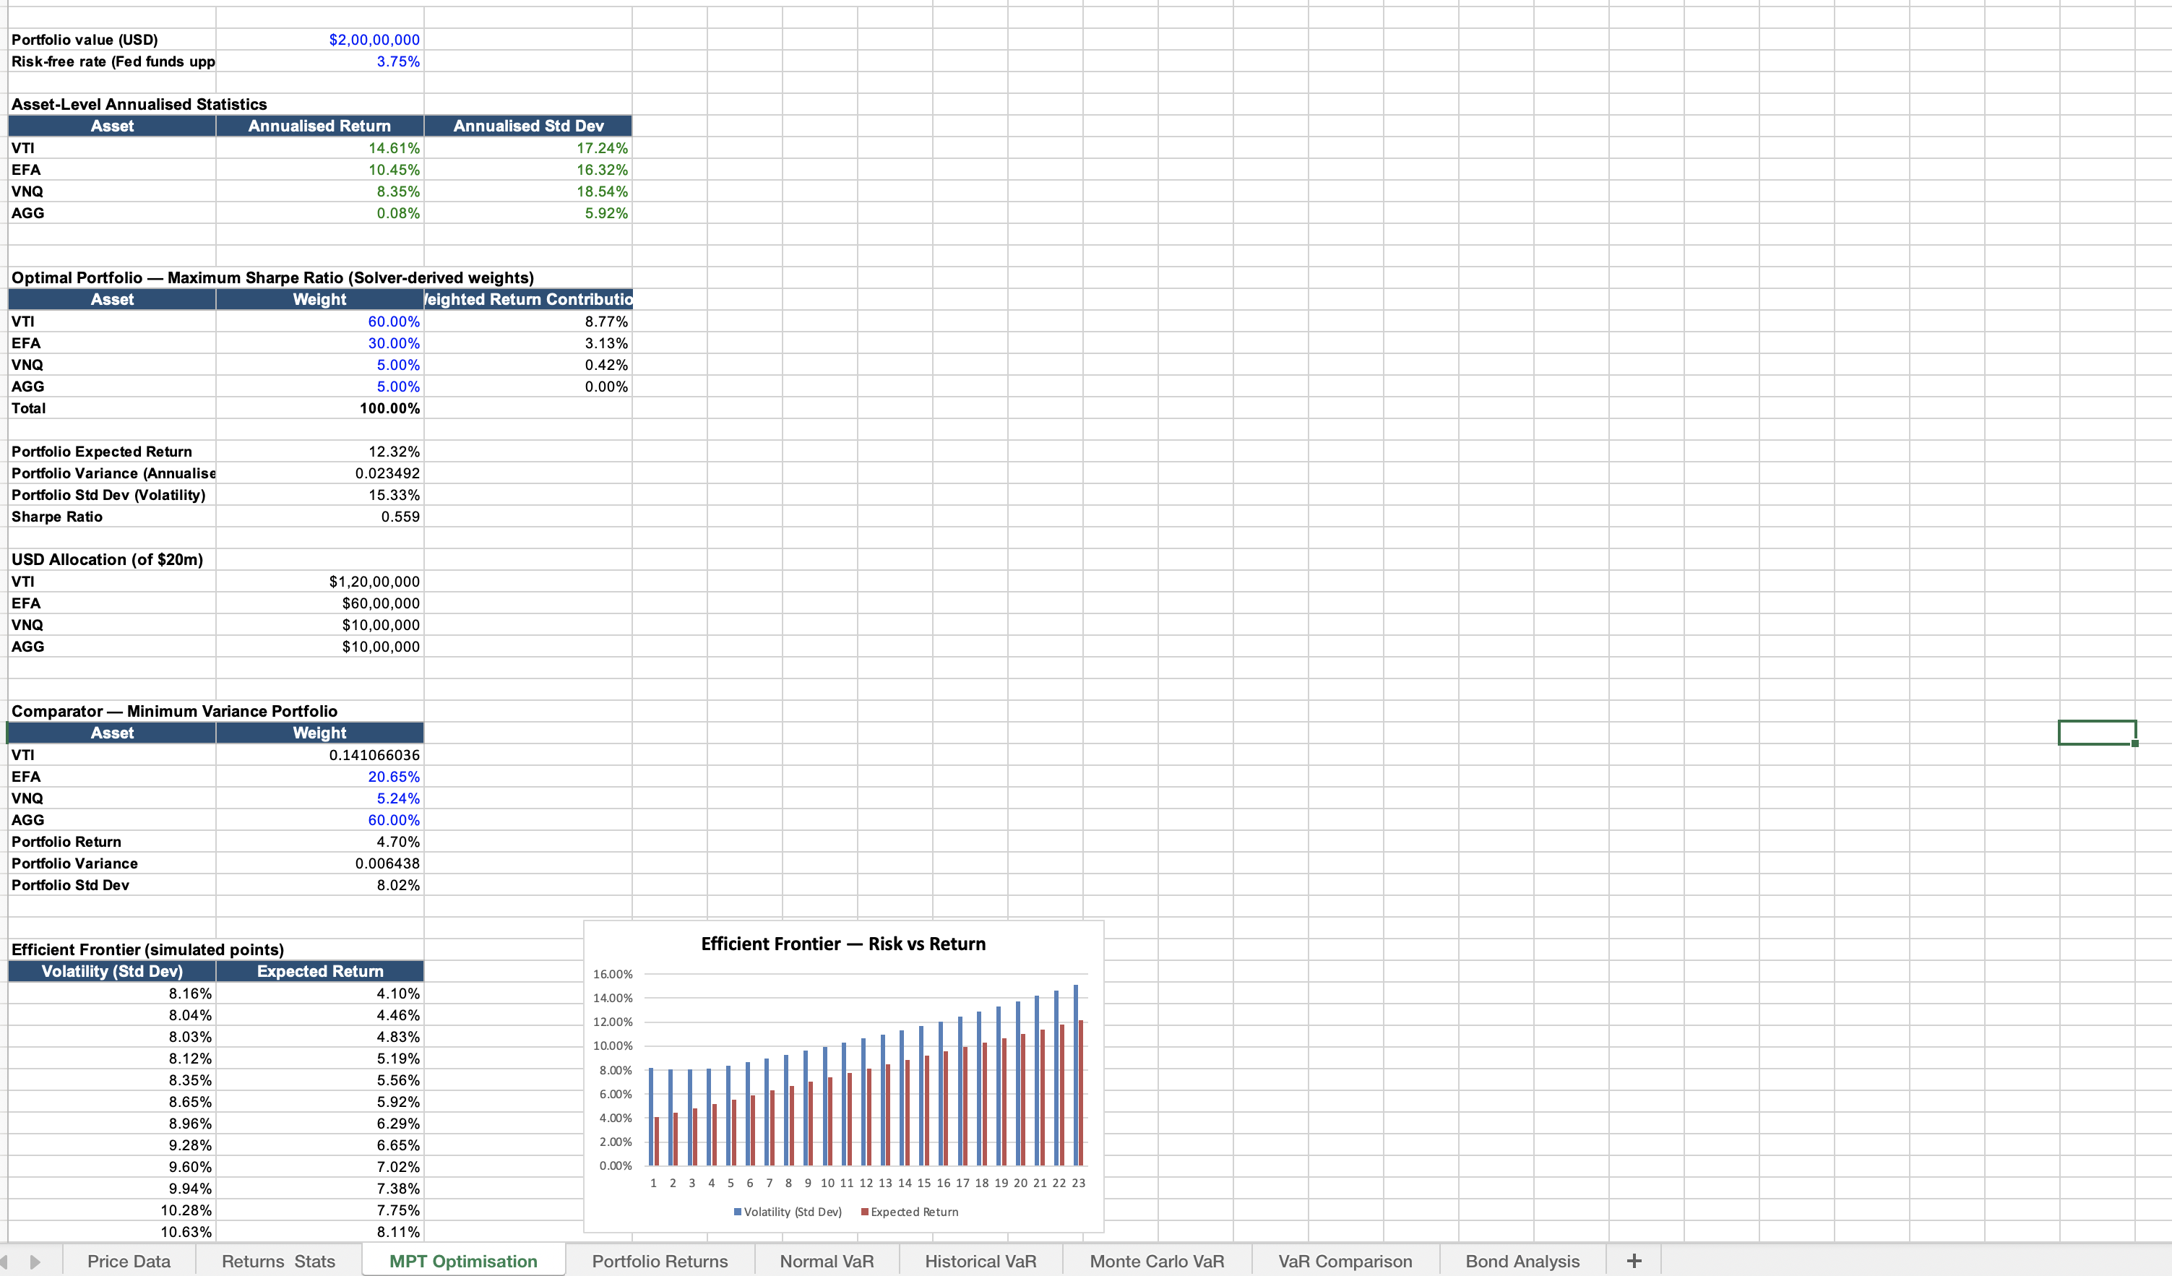
Figure 1: MPT Optimisation
This not only passes seriously on the face validity test, but when an unconstricted optimisation is used on a sample that contains a specific bad bond period will under-allocate to fixed income as compared to what most institutional investors would consider risk-prudent on such a large mandate (Okoro & Ayaba, 2023). The 5 percent floor is an unnatural, judgement-override of the logic of optimisation as such, and it has a lower limit of diversification which the pure logic of historical optimisation would not select in itself. Since the Fed has been able to sustain its rates at 3.503.75 percent and inflation remains in the high range, capacity to maintain the same even through the slight quantity of bond holdings can be seen as a neutralizing element to the income in case of equities correction. This 60/30/5/5 is not something to consider as an endpoint but a starting point where one must proceed to break down some more scenarios but needs to be rebalanced after some time as correlations and the likelihoods of returns will vary.

3. More Precious Market Risk Measurement
On the best portfolio made with the best portfolio to quantify its market risk, Section A has presented some Value-at-Risk measures, comparing the three differing methods to its estimation.
Normal (Parametric) VaR: VAO is provided on the mean and standard deviation of the portfolio that are connected towards the z-score of the z-score. This created a 1-day VaR of 95 percent confidence of 1.54 percent, or 307,962 and a 99 percent confidence VaR of 2.20 percent, or 439,610.
Historical Simulation: VaR is not based on values of any kind of normality, but relies on the weighting in the historical data of the portfolio and derives VaR using the empirical 5th and 1st percentile (Cheng, 2025). As it is an observed data, it always contains whatever fat tails, or stress events it contains in the sample, such as the 2022 drop. This produced a 95 percent VaR of 1.47 percent ($293,602) and a 99 percent VaR of 2.63 percent ($525,173).
Monte Carlo Simulation: VaR takes ten thousand simulated daily returns with the help of multiple variables normal distribution with the parameterisation based on the historical mean returns and covariance matrix and optimally find the weights to apply in each situation to generate ten thousand simulated daily returns. This produced a 95 percent VaR of 1.56 percent ($312,173) and a 99 percent VaR of 2.22 percent ($444,402).
Comparison
Method | VaR @ 95% (1-day) | VaR @ 99% (1-day)
Normal (Parametric) VaR | $307,962 | $439,610
Historical Simulation VaR | $293,602 | $525,173
Monte Carlo Simulation VaR | $312,173 | $444,402
Table 3: Comparison of VaR estimates
The three approaches are crowded around (within the range of 95 percent: 294,000 -312,000) but, since it falls in the main body of the distribution, a moderate normality violation will have little impact. The estimates of 99 per cent are significantly deviated. The analytically less informative but more significant comparison between historical Simulation VaR and the Monte Carlo estimation as well as the normal estimation is some 19 percent, which only reflects the real data fat left tail, which normal distribution, by definition, underestimates, which the 2022 concomitant drawdowns illustrate (Likitratcharoen et al., 2023). The Monte Carlo VaR can be described as a close to parameterised track of Normative VaR in that the parameterisation was done on an assumption of a normal distribution; a more fat tailed input distribution would have the likelihood of returning it to the historical value.
There are several reasons of this divergence. Normal VaR would use homogeneous and thin-tailed returns whilst actual returns are usually fat-tailed and skewed (with the extreme negative losses found more than it would be with a normal distribution). Historical Simulation does not enforce this assumption, but entirely relies on whether or not the sample is representative of the risk in the future; a sample that has not yet experienced such a severe episode of stress will understate tail risk, but the sample being used here that has experienced such an extreme episode of stress has provided a more conservative value (Sthembiso Dlamini & Sandile Charles Shongwe, 2026). The Monte Carlo-design is as good as its inputting distribution and is simplified normal scheme used in this example is VaRs thin-tail and inherits such behaviour notwithstanding being more procedurally general. Finally, the fact that correlations between assets approach one in times of market stress, since the diversification process packs up, is observed in historical prices, but not in the two other methods, which merely assume this kind of correlation structure.
Risk Management implications: It also means that the 99 percent gap is that the capital buffer to insure tail-risk losses would be lower with the parametric estimation only; an average manager would capitalise the capital buffer to the bigger estimate. Normally based risk limits (calibrated using VaR) would typically be exceeded in practice more often than the level of confidence in question would suggest, and would not be able to withstand the test of time. The tail-hedging behaviour of index put options or holding higher amounts of Treasury than the 5 percent floor, especially the high-probability, high-severe outcomes that tail-hedging strategies cannot adequately capture, are especially likely to focus logic in tail-hedging strategies. As VaR does not presuppose any losses that were above the limits that it encompasses, all the three methods should be supplemented by stress testing on the premises of a scenario, e.g., by modeling a repetition of the 2022 rate shock (Zhu et al., 2025).
Critical Evaluation: Normal VaR is simple and easy to communicate as well as fails to capture fat-tail risk that is long known in financial returns. The framework of Historical Simulation has no distributional assumptions, and is sensitive to real historical co-movements, but everything is backward looking, in the sense that the opinion about the future of the trading day depends on an average of the 5.5 previous years. The flexibility of Monte Carlo may be the most versatile, though the similar limitation is that only when its input assumptions and the normal-based simulation used here inherits the main issue of Normal VaR. This grounds the common folk wisdom of triangulation between a handful of methods and not to run conclusions based on one estimate, and confirms that model uncertainty is a risk and needs to be actively dealt with as well (Züst et al., 2021).

4. Firm Level credit risk and Bond sensitivity analysis
In this section, the credit risk and interest rate sensitivity of 3.50 percent Senior Notes of the Microsoft Corporation, 12 February 2035 (ISIN US594918BC73), which is un-secured obligation of the 3.50 percent and has a maturity of approximately 8.6 years old are analysed, passing the minimum requirement of 5 years.
Bond Overview: The bond has a fixed 3.50 percent coupon with semi-annual payment rate as opposed to the market rate of approximately 4.4 per cent. At this yield, at full face value of 100 and with a discount, the price determined is approximately, 93.67 of the face value. This indicates the fixed coupon at a lower market yield on similar debt which indicates that market rates have increased since the time of issue; and indicates that the investors are earning via capital gain up to the par as maturity is realised (Zachary et al., 2025).
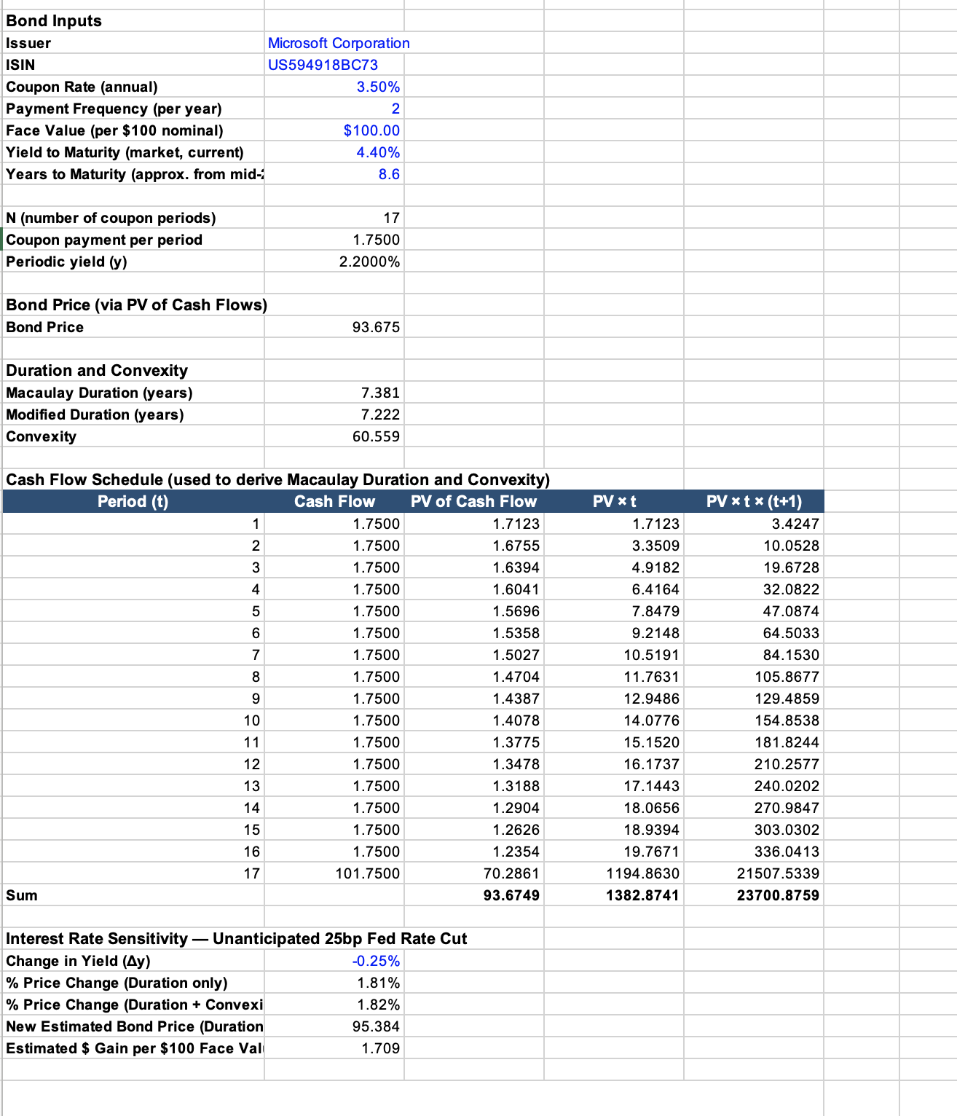
Figure 2: Bond Analysis
Credit Risk Evaluation. Its financial situation is incredibly strong at Microsoft: over 12 months revenue equal approximately 318 billion with the operating margin of 46.3 percent, because of highly profitable and diversified cloud computing, software, gaming, and artificial intelligence infrastructure business. Its total cash of approximately 78 billion, and the debt of approximately 125 billion brings about the debt-to-equity ratio of approximately 30 percent, which is small in nature and will not be affected by the rise in capital expenditure on AI. The projected interest expense one would only pay some 2.4 billion and projected operating income of some 128.5 billion in FY 2025 makes the interest coverage /times interest coverage 54 times, a very wide margin of safety. The near-term cover of obligations can also be confirmed by the approximate values of current ratio (1.28) and the quick ratio (1.14) and significant amount of cash reserves. A mixture of the measures help distinguish an issuer of high-quality credit (USSEC, 2024).
Credit Ratings: The Microsoft bonds are rated best; Standard and Pors have rated it AAA with a stable outlook and Moody has rated it Aaa with an A-1 +/P-1 commercial paper rating. The S&P rating system has given the AAA rating to two American companies Microsoft and Johnson and Johnson, this rating level had 30 years ago an approximate of 60 companies. This takes it way beyond the limit of BBB-minus/Baa3 investment-grade limit which reflects very low amounts of default probability. The notation between agencies has some minor differences depending upon different methodologies (not due to a different perception of who Microsoft is); both agencies share the opinion that Microsoft is the best rating (Zdeněk Zmeškal et al., 2025).
Interest Rate Sensitivity: The movements of the bond price and rates are opposite: when the rates are decreasing, it raises the future value of the fixed cash flows. The Fed funds target of 3.503.75 percent, as at by mid-2026 has yet to be increased to high levels of inflation. The cut in interest rate, which is unexpected, and hence not predetermined would be more likely to raise the price of the bond by 25 basis points. A Macaulay Duration of the bond of approximately 7.38 years offering a Modified Duration of approximately 7.22 years and convexity of approximately 60.6 to perfect the bigger shifts. By utilizing both of them on a negative shock of -25bp, an approximate price change of +1.82 percent would be achieved which would bring the new price point to approximately; 95.38 as compared to 93.67. This is in line with the profile of duration: by 0.72 percent sensitivity over 100bp, you would suggest that a price was drifting by 25bp would cause the price to change by an average of 1.8 percent and this calculation is consistent with that (Zhu et al., 2025).
Additional Risks: As a callable bond, Microsoft is able to redeem the notes earlier, in case there is an increased and continued drop in the rate and capped the positional hence adding risks of reinvestment. The identical time that gives an upside in the case of a rate-cut scenario would generate a similar loss in the event that the rates did rise and this is relevant in the present position whereby the Federal Reserve had a high position particularly in the long term. The spreads of credit can go up to an AAA issuer, to some extent nullifying rate-led gains, during periods of market distress.
Conclusion. This is an excellent credit offering with high amount of rate-sensitivity to duration, which would be best sold to investors who want high-quality and long-duration exposure and low risk of default, would perform well in a rate-cutting environment. However it is not a defensive, low-volatility holding, its below-average pricing and term contain a risk, and would be best viewed as high-quality and rate-sensitive, which should be in a diversified fixed-income sleeve, not a cash-equivalent (Tholl et al., 2021).

5. Strategic policy statement design Oversight and investment
Client Profile: The interviewee is a 45-year old senior marketing executive of a fortune 500 company, a single-parent of a six year old, earns USD 1,000,000 income per year and has an average level of financial literacy. According to normal life-cycle, she is at her best income earning years, and the long horizon prefers a growth-tilted allocation to her. Her status as a single parent is an indication not of a high volatility, aggressive style as the degenerative down turn would be an insult to family security when she is the one to provide the security. Her excellent commitment to the UN Sustainable Development Goals should underpin the strategy and governance (Abideen et al., 2023).
Objectives: The general intention is to enjoy a growth in wealth in the long-term, even greater than the inflation rate, to retire and look after her child after she retires and be in simple and outcome-selective language since she is highly enlightened on money (McCoy et al., 2020). She would best be characterised as having a moderate risk profile: she has real ability to take risk because of high income but the role of sole-provider would imply that she needed to channel her risk-taking more in accordance with an income-based appraisal. It all depends on diversification and downside protection as identified in Section A as the pillar to balancing growth and downside protection.
Constraints: The time frame is multi-decade and heterogeneous: we can have a retirement planning of 15-20 years, but immediate needs, connected with the raising of her child, should also claim their portion in the portfolio of being liquid and less risky. Liquidity position is middle range; a 3-6 months buffer of cash which will not be included in a portfolio invested will be needed, otherwise it will have to sell in a bad market. With high earner, it is necessary to prioritize on tax-advantaged structures; location of assets tax-efficiency whereby the assets which are not very tax-efficient like bonds are placed in tax-efficient wrappers. Since she is a believer in the SDG, ESG screening and/or thematic investment ought to be featured in her portfolio according to her values (Eldomiaty et al., 2026).
Recommended Strategy: A satellite approach of core-satellite is suggested. The simple, majority, position should consist of low cost passive index funds that tracks the assets discussed in Section A, and that has a reliable, cheap exposure. This can be then used to allocate a smaller percentage to satellite allocations which can be concentrated around actively managed or ESG-thematic strategies in which a higher fee would indicate a sense of sincerity. This connects to Section A: the Max Sharpe portfolio built in the same section, and a Sharpe Rating of 0.559, can be an actual benchmark to which the satellite managers should be measured, net of costs, which most active managers can never achieve, even in the long-run.
Strategic Asset Allocation
This is physically more so than is true of the pure Max Sharpe optimization in Section A, hence suggestive of the fact that the risk-taking of a specific client in a real-life situation encompasses more of his or her bonds and cash, and a less risk-averse position, will be justified by the client-specific risk-taking and the personal obligations of the client taken in a binding way (Addo et al., 2025).
ESG and Sustainability: The reasoning of negative screening or thematic investing is rather justifiable given the above values of Alexandra mentioned and there is some evidence to imply that the systematic cost to returns may not necessarily be a cost of ESG integration. However, the ESG screening can result in less diversification in the investable universe and risk than would otherwise exist with a free portfolio; eliminating all of a sector can alter the set of connections in a model as simple as that in Section A. This is a trade-off that needs to be actively noted: both diversified and broadly ESG index funds would be superior in the sense of core allocation, and concentrated virtually thematic in the satellite sleeve.
Behavioural Finance: The loss aversion concept applies particularly well, since Alexandra is the sole provider and as such, she can experience loss more than the equivalent gains which will prompt her to sell during the bad times in panics. It is minimized by making the reporting focused on long-term reporting, based on goals, and not on the fluctuations in the short-term (Ikram et al., 2023). Secondly is overconfidence; being a successful executive, she might underestimate risk or be tempted to concentrate bets since they are not in line with the agreed plan. Both risks are handled in the disciplined composition of the IPS itself: a predetermined distribution, procedural re-balancing, and formalized governance restrains the extent of decisions fueled by emotions to spurt over the strategy during a market panic or ecstasy.
Monitoring and Governance: The portfolio should be re-assessed at minimum of once in a year and its performance should be established as per the strategy bench-mark with rebalancing to be undertaken to desired weights as well as the ESG mandate should be reviewed as required. The IPS should be revisited upon a material change of life i.e. change of career or income, inheritance or change of need with the increase of her child since such changes may alter the risk capacity and goals to such a level that they will necessitate a formal re-assessment (Nabeshima et al., 2025).

6. Conclusion
It has been demonstrated in this report that it is the mixture of objective measurement of the portfolio and critical, situational evaluation and not the mechanical operating of any of the above models per se that forms the proper management of portfolios. Section A showed that an optimal Sharpe Ratio portfolio of four imperfectly correlated category of assets taking a 60/30/5 percent of VTI, EFA, VNQ and AGG as a single portfolio, maximises the Sharpe Ratio, and thousands of years of all-historical optimisation of portfolios that have been underperforming at different points in history show that defensive investment allocations are under-allocated.
Section B substantiated the argument that none of the individual VaR techniques should be used alone: though, all three VaR techniques (Normal, Historical, and Monte Carlo VaR) scored the same at the 95 percent confidence level, they all differed more at the 99 percent confidence level, with two of them (Hypothetical Simulation VaR and parametric estimate) asserting themselves to be significantly different, and it has direct applications that are directly connected with the aspect of capital adequacy, risk limits and even tail-risk hedging. Part C demonstrated that even with a very high-quality issuer holding such a high AAA, Axa-rating as Microsoft, there exists a non-trivial interest rate risk even in isolation of duration, or that credit risk and interest rate risk are not vertical, and need to be considered, even in the case of a borrower where the default risk is extremely small.
Section D was the discovery of how to translate the quantitative analysis of the quantitative analysis into a really useful Investment Policy Statement is to overlay client-specific constraints, values and behavioural awareness on the technical optimisation. The distribution proposed by Alexandra has been developed in such a way that has a relatively higher share of bonds and cash especially compared to the pure Max Sharpe optimisation of Section A since the reality of risk bearing and psychology of an individual client also counts a lot as much as the maths of an efficient frontier counts a lot. Combined, it appears that sound investment decision-making is dependent on a trade-off between highly-quantitative modelling and the qualitative judgement necessary to take advantage of the shortcomings of such modelling, as well as to tailor the modelling to the requirements of the investor who is to be served.

References
Abideen, Z. U., Ahmed, Z., Qiu, H., & Zhao, Y. (2023). Do Behavioral Biases Affect Investors’ Investment Decision Making? Evidence from the Pakistani Equity Market. Risks, 11(6), 109–109. https://doi.org/10.3390/risks11060109
Addo, J. O., Cúg, J., Keelson, S. A., Amoah, J., & Petráková, Z. (2025). Behavioral Risk Management in Investment Strategies: Analyzing Investor Psychology. International Journal of Financial Studies, 13(2), 53. https://doi.org/10.3390/ijfs13020053
Ali, F., Muhammad Usman Khurram, Ahmet Şensoy, & Xuan Vinh Vo. (2024). Green cryptocurrencies and portfolio diversification in the era of greener paths. Renewable & Sustainable Energy Reviews, 191, 114137–114137. https://doi.org/10.1016/j.rser.2023.114137
Almeida, J., & Gonçalves, T. C. (2022). Portfolio Diversification, Hedge and Safe-Haven Properties in Cryptocurrency Investments and Financial Economics: A Systematic Literature Review. Journal of Risk and Financial Management, 16(1), 3. https://doi.org/10.3390/jrfm16010003
Cheng, Y. (2025). Monte Carlo-Based VaR Estimation and Backtesting Under Basel III. Risks, 13(8), 146. https://doi.org/10.3390/risks13080146
Eldomiaty, T., Azzam, I., Fouad, J., & Abdelazim, M. H. (2026). Distance to Default and Misspecification of Corporate Economic Value Added. Journal of Risk and Financial Management, 19(5), 327. https://doi.org/10.3390/jrfm19050327
Ikram, B., Fouad, B. E. H., & Sara, C. (2023). An Exploration of Overconfidence and the Disposition Effect in the Stock Market. International Journal of Financial Studies, 11(2), 78. https://doi.org/10.3390/ijfs11020078
Likitratcharoen, D., Chudasring, P., Pinmanee, C., & Wiwattanalamphong, K. (2023). The Efficiency of Value-at-Risk Models during Extreme Market Stress in Cryptocurrencies. Sustainability, 15(5), 4395. https://doi.org/10.3390/su15054395
Malhotra, D. K. (2024). Evaluating the Performance of Real Estate Exchange-Traded Funds. Journal of Risk and Financial Management, 17(1), 7. https://doi.org/10.3390/jrfm17010007
McCoy, J., Palomino, F., Perez-Orive, A., Press, C., & Sanz-Maldonado, G. (2020). Interest Coverage Ratios: Assessing Vulnerabilities in Nonfinancial Corporate Credit. Www.federalreserve.gov.https://www.federalreserve.gov/econres/notes/feds-notes/interest-coverage-ratios-assessing-vulnerabilities-in-nonfinancial-corporate-credit-20201203.html
Nabeshima, H., Khan, M. S. R., & Kadoya, Y. (2025). Overconfidence and Investment Loss Tolerance: A Large-Scale Survey Analysis of Japanese Investors. Risks, 13(8), 142. https://doi.org/10.3390/risks13080142
Okoro, C. S., & Ayaba, M. M. (2023). Research Trends and Directions on Real Estate Investment Trusts’ Performance Risks. Sustainability, 15(6), 5436–5436. https://doi.org/10.3390/su15065436
Sthembiso Dlamini, & Sandile Charles Shongwe. (2026). Comparative Analysis of Tail Risk in Emerging and Developed Equity Markets: An Extreme Value Theory Perspective. International Journal of Financial Studies, 14(1), 11–11. https://doi.org/10.3390/ijfs14010011
Tholl, J., Basse, T., Meier, S., & Rodriguez Gonzalez, M. (2021). Risk premia and the European government bond market: new empirical evidence and some thoughts from the perspective of the life insurance industry. Zeitschrift Für Die Gesamte Versicherungswissenschaft, 110(1), 49–78. https://doi.org/10.1007/s12297-021-00503-2
USSEC. (2024). Form 10-K MICROSOFT CORPORATION. Sec.gov. https://www.sec.gov/Archives/edgar/data/0000789019/000095017025100235/msft-20250630.htm
Yahoo finance. (2025). Vanguard Real Estate Index Fund ETF Shares (VNQ) Stock Historical Prices & Data - Yahoo Finance. Yahoo Finance. https://finance.yahoo.com/quote/VNQ/history/
Yahoo. (2024). iShares Core U.S. Aggregate Bond ETF (AGG) Stock Historical Prices & Data - Yahoo Finance. Yahoo.com. https://finance.yahoo.com/quote/AGG/history/
Zachary, G. P., Hall, M., & Montevirgen, K. (2025, April 10). Microsoft Corporation. Britannica Money. https://www.britannica.com/money/Microsoft-Corporation
Zdeněk Zmeškal, Dluhošová, D., Karolina Lisztwanová, & Iveta Ratmanová. (2025). A Profitability and Risk Decomposition Analysis of the Open Economy Insurance Sector. Risks, 13(7), 129–129. https://doi.org/10.3390/risks13070129
Zhu, Y., Shairil Izwan Taasim, & Daud, A. (2025). Volatility Modeling and Tail Risk Estimation of Financial Assets: Evidence from Gold, Oil, Bitcoin, and Stocks for Selected Markets. Risks, 13(7), 138–138. https://doi.org/10.3390/risks13070138
Züst, S., Huonder, M., West, S., & Stoll, O. (2021). Life-Cycle Oriented Risk Assessment Using a Monte Carlo Simulation. Applied Sciences, 12(1), 8. https://doi.org/10.3390/app12010008

